✴

**TIP**

As you add steps to the experience, move each these “Five Es” the left or right depending on the scenario you are documenting.

# Document an existing experience

Narrow your focus to a specific scenario or process within an existing product or service. In the **Steps** row, document the step-by-step process someone typically experiences, then add detail to each of the other rows.

# Entice

**SCENARIO**

**Browsing, booking, attending, and rating a local city tour**

How does someone initially become aware of this process?

# Enter

What do people experience as they begin the process?

# Engage

In the core moments in the process, what happens?

# Exit

What do people typically experience

as the process finishes?

# Extend

What happens after the experience is over?

## Steps

REDUCTION IN PHYSICAL AND ENVIRONMENTAL HAZARDS

SYSTEMS WHERE LEAKAGES CAN BE DETECTED AND HARAZDOUS CAN BE REDUCED

USE DIGITAL SYSTEMS AND RECORD LEAKAGES

SAFETY OF WORKERS

TO OVERCOME HARAZDOUS CONDITIONS IN WORKING AREA

CREATE CUSTOMER ACCOUNT

What does the person (or group) typically experience?

## Interactions

CLOUD STORES DATAS

LEAKAGES ARE DETECTED

What interactions do they have at each step along the way?

GIVES REAL TIME INFORMATION

DATAS CAN BE ACCESSED ANYTIME

MOBILE APPLICATION TO SEND ALERT

SENSORS ARE UTILIZED

SMART MONITORING SYSTEM

**People:** Who do they see or talk to?

**Places:** Where are they?

**Things:** What digital touchpoints or physical objects would they use?

## Goals & motivations

GIVE ALERT MESSAGES IF THE DATA GOES OVER THE SAFETY LIMIT

IDENTIFY AND INSPECT HAZARDOUS AREA

THE IDEA TO CHANGE THE WORKING PLACE INTO HARMLESS ENVIRONMENT

CULTIVATE SAFE ENVIRONMENT

At each step, what is a person’s primary goal or motivation? (“Help me...” or “Help me avoid...”)

WORKERS HAVE A SENSE OF SECURITY

SAFE WORKING CONDITIONS

## Positive moments

WORTHY

EFFECTIVE AND PROFITABLE

USER FRIENDLY

DETECTS LEAKAGE OF GASES AND FIRE

NO RISK FACTOR

What steps does a typical person find enjoyable, productive, fun, motivating, delightful, or exciting?

## Negative moments

What steps does a typical person find frustrating, confusing, angering, costly, or time-consuming?

LIMITED

RANGE CAN

DIIFICULT TO DETECT IF OTHER PARTICALS ARE PRESENT ONTOP OF THE DETECTOR

TEDIOUS PROCESS

REQUIRES INTERNET FACALITY THROUGHOUT THE WHOLE PROCESS

ONLY BE

DETECTED

## Areas of opportunity

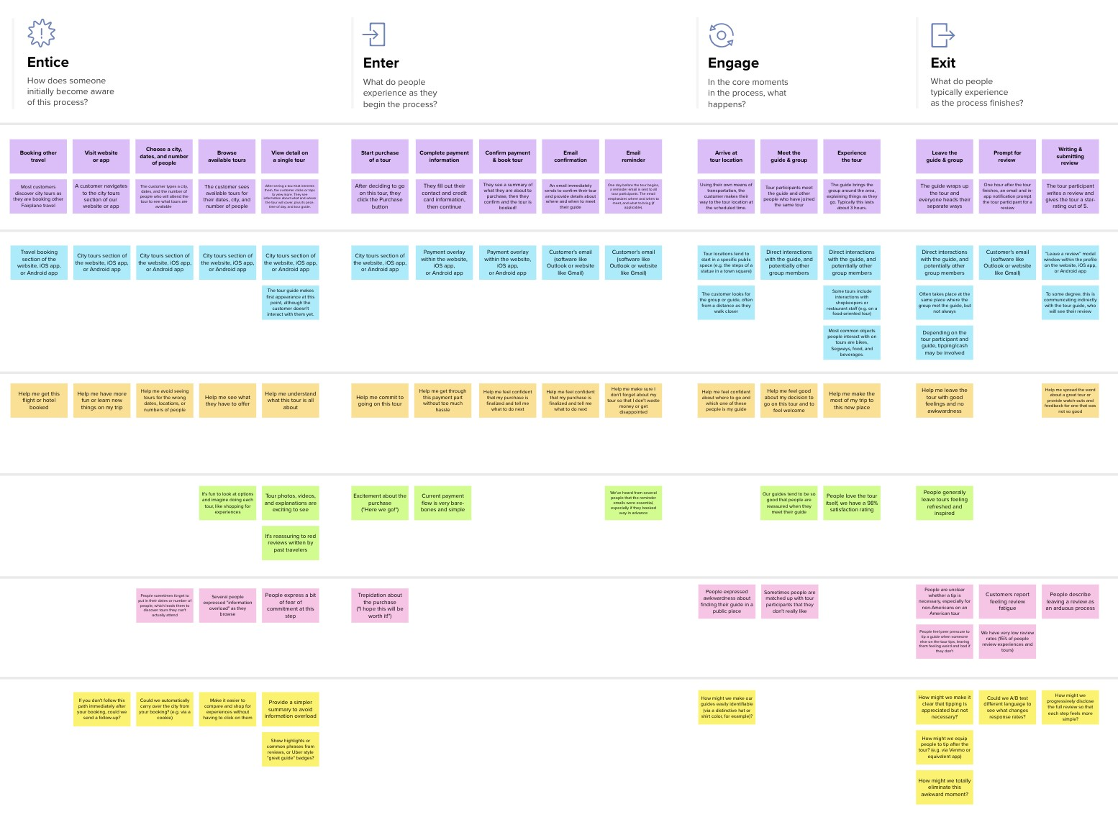

**Need some inspiration?**

See a finished version of this template to kickstart your work.

[**Open example**](https://app.mural.co/template/f59f644b-b4b4-47b5-9ed6-3a8c71ceb612/896b31fe-5597-40ef-9b06-3811a1a45ace)

[**Share template feedback**](https://muralco.typeform.com/to/CiqaHVat?typeform-source=app.mural.co)

Created in partnership with

**Customer experience journey map**

Use this framework to better understand customer needs, motivations, and obstacles by illustrating a key scenario or process from start to finish.

When possible, use this map to document and summarize interviews and observations with real people rather than relying on your hunches or assumptions.



ENVIRONMENTAL ADAPATIONS ARE QUITE DIFFICULT

**Template**

How might we make each step better? What ideas do we have? What have others suggested?

ENCHACE HARMLESS WORKING CONDITIONS

ADDITIONAL INFORMATIONS FOR QUERIES

TO WORK IN A PEACEFUL ENVIRONMENT

SENSE OF CONTENMENT

BETTER AND RELIABLE SYSTEM